**Graphical User Interface Document**

**Carlos Rios, Ivan Sosa, Satish Subramanian, Phillipe Hehn, Derek Jones**

**CS 3402**

**Yuchou Chang**

Table of Contents

**Login** 3

**Views** 4

**Staff View** 4

**Manage Staff Tab** 4

**View Students Tab** 5

**Manage Class Material** 6

**Manage Assignments** 7

**Admin View** 8

**Add Users Tab** 8

**Add Courses Tab** 9

**Manage Users Tab** 10

**Manage Courses Tab** 11

**Student View** 12

**Manage Classes Tab** 12

**View Class Material Tab** 13

**Manage Assignment Tab** 14

# **Login**

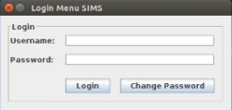

Username: Enter your username

Password: Enter your password

Defaults:

Admin: Admin

Student: *FirstnameLastname*

Teacher: *FirstnameLastname*

Login Button: Login to your account

Change Password Button: Change user password

This is the screen that teachers, admins, and students will first see when they attempt to log in to the software system. The data for the logins are stored as hashed strings in the database.

# **Views**

## **Staff View**

### **Manage Staff Tab**

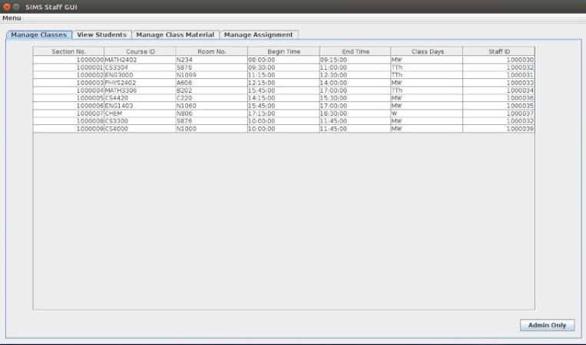

Shows Class information for staff member. The data displayed reflects the database.

Admin Only Button: Allows that staff member to change to admin mode if permission is available.

### **View Students Tab**

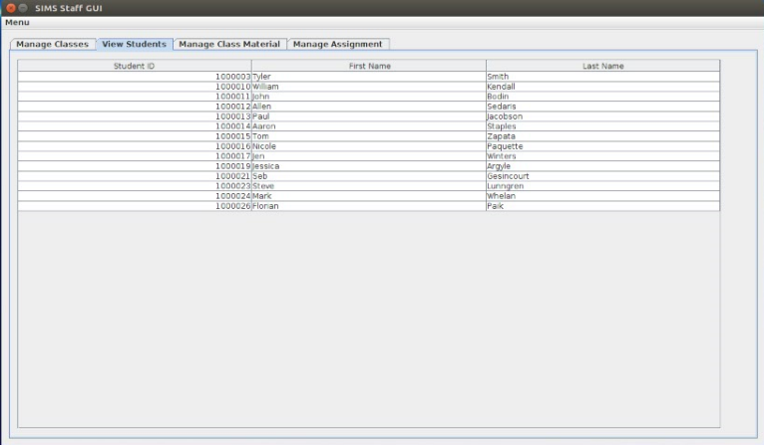

Shows the Staff each student that is tied to a certain course.

### **Manage Class Material**

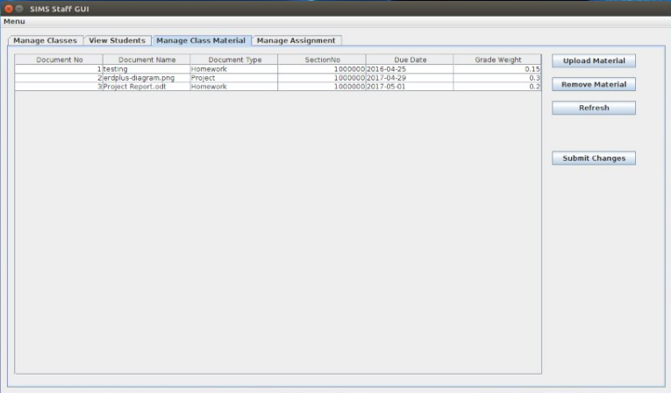

Allows for the modification of all class materials for each course.

Upload: Uploads a class material(PowerPoint, Word, Excel, PDF, etc.) for the class to view

Remove Material: Removes the material from the database

Refresh: Reflects changes made to class materials

Submit Changes: Commits changes to class materials.

### **Manage Assignments**

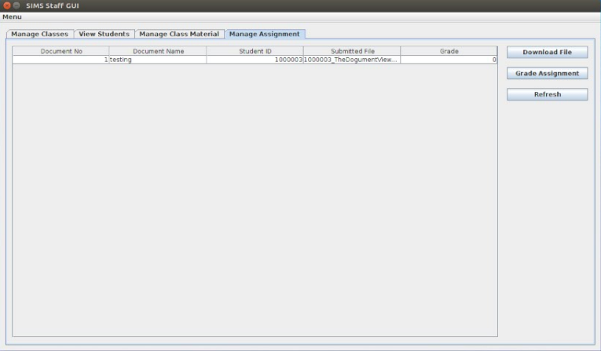

Allows changes to be made to assignments submitted by students.

Download File: Downloads the selected assignment submitted by the student

Grade Assignment: Grades the assignments submitted by the student

Refresh: Reflects changes made to the assignments

## **Admin View**

### **Add Users Tab**

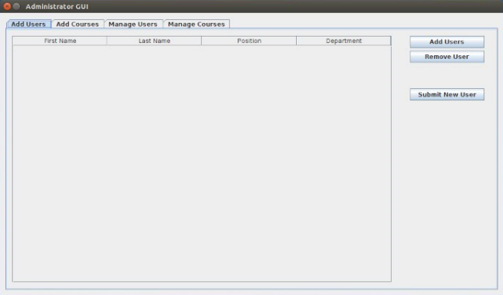

Allows for the addition and deletion of users contained the database.

Add Users Button: Allows Admin to add Students, Teachers or other Admin accounts.

Remove User Button: Allows Admin to remove Students Teachers or Admin accounts.

Submit New User: Commits the addition of accounts.

### **Add Courses Tab**

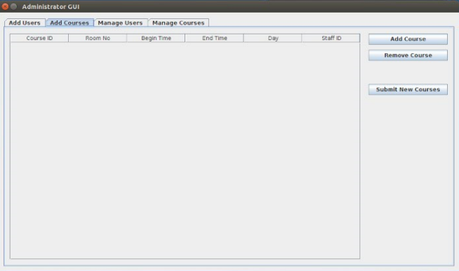

Allows the addition and deletion of courses.

Add Course: Allows admin to add class courses.

Remove Course: Allows admin to remove courses.

Submit New Courses: Commits the addition of new class courses.

### **Manage Users Tab**

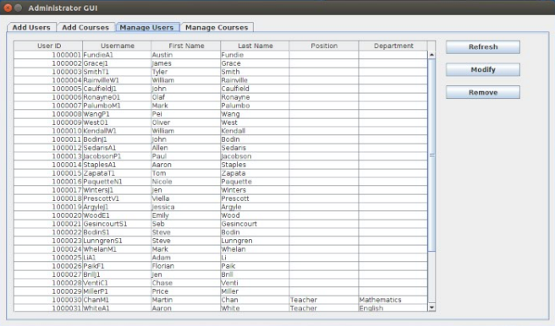

Allows the modification of all user information in the database

Refresh: Refreshes the database information

Modify: Changes a field of a user entry

Remove: Removes a field of a user entry

### **Manage Courses Tab**

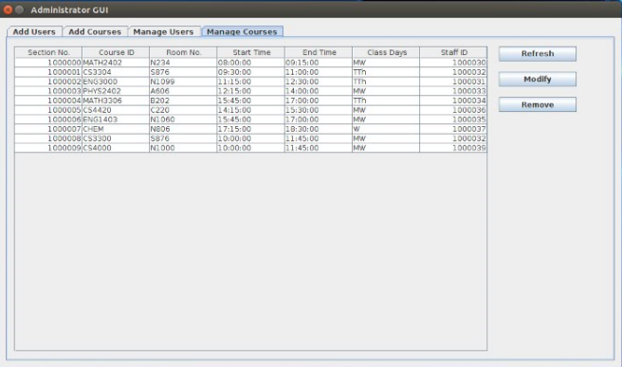

Allows the modification of all courses in the database

Refresh: Refreshes the database information

Modify: Changes a field of a course entry

Remove: Removes a field of a course entry

## **Student View**

### **Manage Classes Tab**

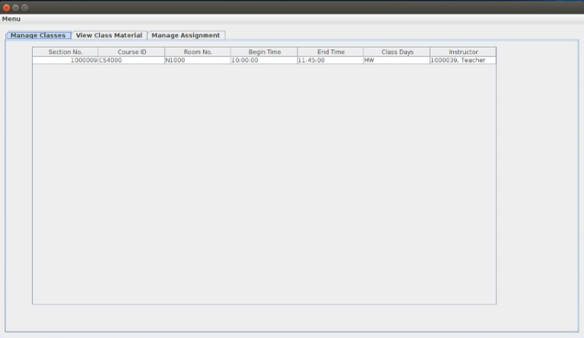

Allows the student to choose classes for his schedule from posted courses

### **View Class Material Tab**

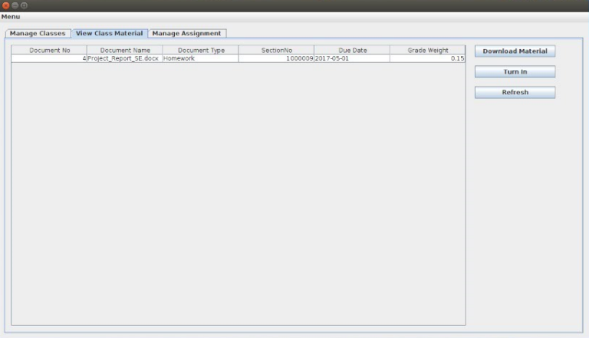

Allows the student to download assignments and turn in assignments.

Download Material: Downloads the class material(PowerPoint, Word, Excel, PDF, etc.)

Turn in: Submit an assignment associated with a Class Material.

Refresh: Reflects if assignments were turned in.

### **Manage Assignment Tab**

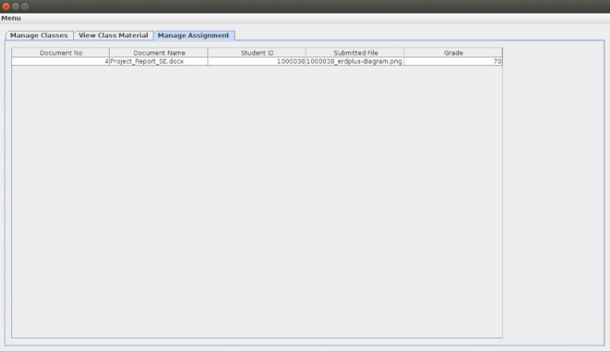

Shows assignments due, assignments turned in, and grades for turned in assignments.